Good Morning Dragons! 
Today is Wednesday, April 15, 2020. This is day 23 of our Discovery Home School Adventure.

Today is going to be a chilly day! I wonder if you could find an interesting way to sort somethings at home, maybe your toys to create a math problem or a pattern?

Check in this afternoon for pictures of your friends and teachers’ sorted objects that create a math problem or pattern. Don’t forget to be practicing reading and math facts.
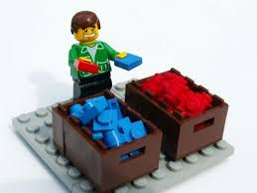
Love,
Ms. Castner and Mrs. Dame-Marino
(common sight words are highlighted in blue K/1 students should be able to read the blue words and highlighted numbers in the daily message)
Email pics to kjacobson@rochesterdiscovery.com or send through our school wide remind app

