Good Morning Crew! 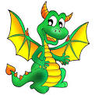
Today is Wednesday, April 22, 2020. This is day 28 of our Discovery Home School Adventure.

Today is Earth Day! A day for us to love our earth a little extra. Yesterday you did some research about our native birds. Native means local to our area. A Robin is a native bird to Rochester. Some kinds of Parrots are native bird of Northern Mexico.
Below are some creative ways to feed our birds. Can you make a bird feeder? There A LOT of ideas on the internet! Send us pictures of your creations.
Check in this afternoon for pictures of your friends and teachers’ birdfeeder creations.
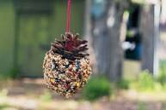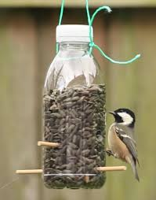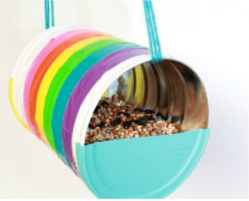
Love,
Ms. Castner and Mrs. Dame-Marino
(common sight words are highlighted in blue K/1 students should be able to read the blue words and highlighted numbers in the daily message)
Email pics to kjacobson@rochesterdiscovery.com or send through our school wide remind app

