
Attention Students and Families

Do you want a chance to win this family fun pack???
Make sure your student(s) complete the required Math and Reading assessments by Friday and you will be entered into the drawing.
We will choose 2 winners one from K-2 and one from 3-6.
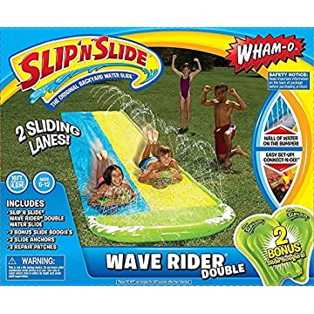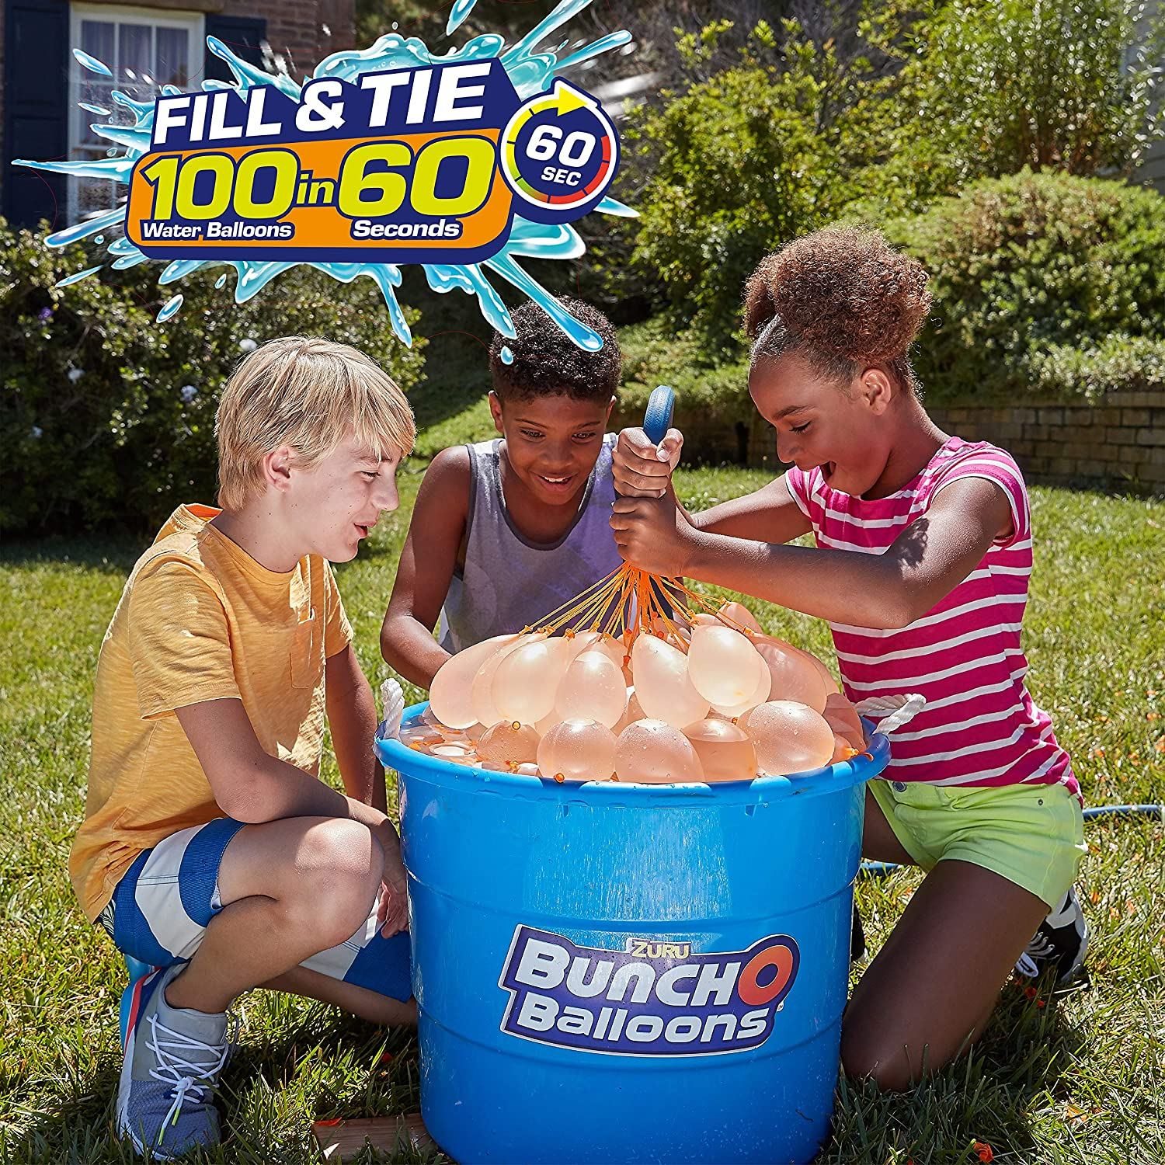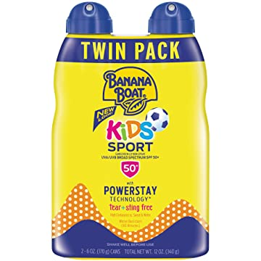

Good Luck and do your best!
Ms. Castner

Do Better. Be Better. It’s a Brand-new Day!

